HW #3 Rootfinding

0. Executive Summary
A hybrid method of bisection method and Newton method was used to compute the effective annual interest rate and the interest rate is 20.6928%.

- Statement of Problem
Compute the effective annual interest rate that if we deposit 1000 dollar monthly then the total account will grow to 1 million in 15 years. We will Use bisection method to compute to within one significant digit and then turn to Newton method to get a solution to machine accuracy.

- Description of The Mathematics
Bisection method:
First choose two ending points that the function values at these two points have opposite signs. Then choose the middle point and compare the sign of function at middle point with function value at two ending points, choose the middle point and one of ending points which has opposite sign with the middle point as new two ending points. Follow this irritation until it converges.
Since: 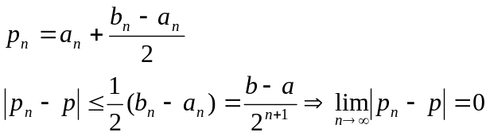
The convergence is guaranteed.

In addition, since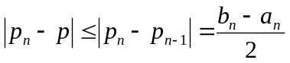, we may choose 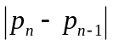 as the upper bound of error. When p is small, we may choose the criterion of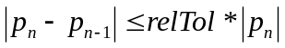, otherwise the criterion of 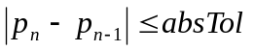 is useable.
So the final criterion to check if it is converge is:
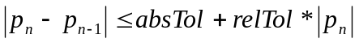

At last, we may calculate the maximum round number when it converge given two starting points, absolute tolerance and relative tolerance.

Newton’s method:
Starts with an initial guess which is reasonably close to the true root, then the function is approximated by its tangent line, and the x-intercept will typically be a better approximation to the function's root than the original guess. Choose the x-intercept as new starting point and follow the irritation until it converges. 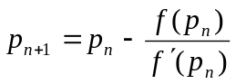
Newton’s method needs two assumptions: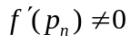, and the starting point is close enough to the true root. Under these assumptions, the Newton’s method can guarantee the convergence.
The Newton’s method converges quadratic.
Using Taylor extension: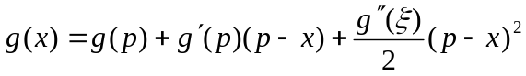, where 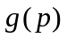=p, 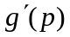=0, choose x=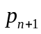, then: 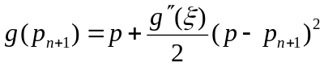.
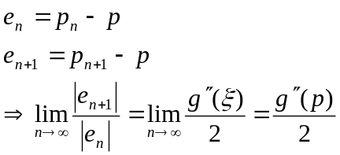
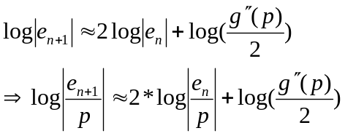
From the formula above, since Newton’s method can converge so quickly, if we start from the initial point that within one or two significant digits, there will be less than 6 irritations that it convergent to machine accuracy.
The last should be talked about is the convergence criterion:
Since: 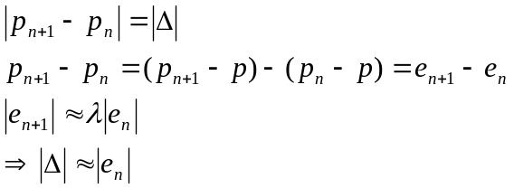
We may use the criterion like the one we use in bisection method: 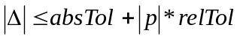

- Description of the Algorithm
In this problem, I use two methods, bisection method and Newton method as above. The code listed below.
- Results
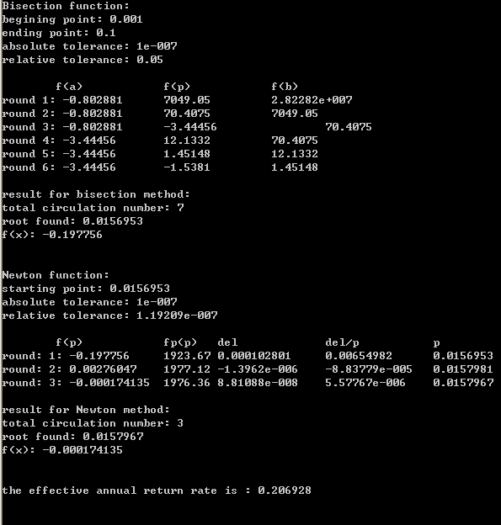
First use bisection method, with ending points 0.001 and 0.1, and after six rounds to find a root, 1.56953%, within 1 effective digital. Then use this value as a start-value to run Newton method, and after 3 rounds I get a final result, 1.57967%, to IEEE single precision machine accuracy. Then using the formula 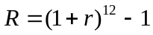 to get effective annual return rate: 20.6928%

- Conclusions
From mathematics listed above, we usually use del,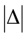, to approximate 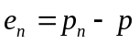 which is 8.81088e-8 less than single precision machine epsilon. Also the del,, decrease nearly quadratically, as the mathematics tells me.
So it is reasonable to expect the Newton method converge and the root found is right.

- Code Listing

<rootfinding.h>
#define ROOTFINDING_H

#include "FLOAT.h"
#define FLOAT float

class rootfinding
{
public:

FLOAT Bisect(FLOAT (*f1)(FLOAT x), FLOAT a, FLOAT b, FLOAT absTol, FLOAT relTol);
FLOAT Newton(FLOAT (*f1)(FLOAT x), FLOAT (*f2)(FLOAT y), FLOAT startvalue, FLOAT, FLOAT);
FLOAT Solve(FLOAT (*f1)(FLOAT), FLOAT (*f2)(FLOAT), FLOAT a, FLOAT b, FLOAT absTol, FLOAT relTol);
private:
int sign(FLOAT (*f)(FLOAT), FLOAT i);
};

<rootfinding.cpp>

#include "rootfinding.h"

#include <math.h>
#include <float.h>
#include <iostream>
using namespace std;

int rootfinding::sign(FLOAT (*f)(FLOAT),FLOAT i)
{
if (f(i)>0) return 1;
else return -1;
}

FLOAT rootfinding::Bisect(FLOAT (*f1)(FLOAT x), FLOAT a, FLOAT b, FLOAT absTol, FLOAT relTol)
{
if (sign(f1,a)*sign(f1,b)>0)
{
cout<<"please choose ending points with opposite sign"<<endl;
return 0;
}
else
{
cout<<"Bisection function: "<<endl;
cout<<"begining point: "<<a<<endl<<"ending point: "<<b<<endl;
cout<<"absolute tolerance: "<<absTol<<endl<<"relative tolerance: "<<relTol<<endl<<endl;
cout<<"\tf(a)\t\tf(p)\t\tf(b)"<<endl;
int N;

FLOAT minimum;
if (abs(a)<abs(b)) minimum=abs(a);
else minimum=abs(b);

N=log((b-a)/(absTol+minimum*relTol))/log(2.0);
int i=1;
FLOAT p=0;
while (i<=N)
{
p=a+(b-a)/2;
if ((b-a)/2<=absTol+relTol*abs(p)) break;
cout<<"round "<<i<<": "<<(*f1)(a)<<"\t"<<(*f1)(p)<<"\t\t"<<(*f1)(b)<<endl;
if (sign(f1,a)*sign(f1,p)>0) a=p;
else b=p;
i++;
}
cout<<endl;
cout<<"result for bisection method: "<<endl<<"total circulation number: "<<i<<endl<<"root found: "<<p<<endl<<"f(x): "<<(*f1)(p)<<endl<<endl<<endl;

return p;

}
}

FLOAT rootfinding::Newton(FLOAT (*f1)(FLOAT x), FLOAT (*f2)(FLOAT y), FLOAT startValue, FLOAT absTol, FLOAT relTol)
{
cout<<"Newton function: "<<endl;
cout<<"starting point: "<<startValue<<endl;
cout<<"absolute tolerance: "<<absTol<<endl<<"relative tolerance: "<<relTol<<endl<<endl;
cout<<"\tf(p)\t\tfp(p)\tdel\t\tdel/p\t\tp"<<endl;
int i=1;
FLOAT p=startValue;
FLOAT del=-f1(p)/f2(p);
while ((abs(del)>(absTol+abs(p)*relTol))&&(i<=10))
{
cout<<"round: "<<i<<": "<<(*f1)(p)<<"\t"<<(*f2)(p)<<"\t"<<del<<"\t"<<del/p<<"\t"<<p<<endl;
p=p+del;
del=-f1(p)/f2(p);
i++;
}
cout<<"round: "<<i<<": "<<(*f1)(p)<<"\t"<<(*f2)(p)<<"\t"<<del<<"\t"<<del/p<<"\t"<<p<<endl<<endl;
cout<<"result for Newton method: "<<endl<<"total circulation number: "<<i<<endl<<"root found: "<<p<<endl<<"f(x): "<<(*f1)(p)<<endl<<endl<<endl;

return p;

}

FLOAT rootfinding::Solve(FLOAT (*f1)(FLOAT), FLOAT (*f2)(FLOAT), FLOAT a, FLOAT b, FLOAT absTol, FLOAT relTol)
{
FLOAT n;
n=this->Bisect(*f1,a,b,absTol,5*pow(10.0,-2));
return this->Newton(*f1,*f2,n,absTol,relTol);
}

<main.cpp>

#include "rootfinding.h"
#include "Float.h"
#include <iostream>
#include <math.h>
#include <iomanip>

//#define FLOAT double

using namespace std;

FLOAT f(FLOAT i)
{
return pow(1+i,180)-1000*i-1;
}

FLOAT fp(FLOAT i)
{
return 180*pow(1+i,179)-1000;
}

void main()
{
rootfinding a;
FLOAT out=0;
Float m;
FLOAT k=10;

out=a.Solve(*f,*fp,0.001f,0.1f,pow(10.0,-7),m.epsilon(out));
cout<<"the effective annual return rate is : "<<pow(out+1,12)-1<<endl<<endl<<endl;

cin>>out;

}

